

YEAR: 9
SUBJECT: SCIENCE

TEST: Matter
TIME: 40 mins
QUESTIONS: Part A: Multiple Choice Questions (10 marks)
Part B: Short Answer Questions (18 marks)
Part C: Extended Response (5 marks)

TOTAL MARKS: 33 marks

DO NOT WRITE ON OR MARK THIS PAPER

SECTION ONE: Multiple Choice Questions (1mark each)
Answer this section on the separate multiple – choice answer sheet

- Which of the following statements about atoms is true?
- Neutrons and protons are found in the nucleus with the electrons
- The number of neutrons found in the nucleus of an atom is always the same
- Protons circle the nucleus all the time
- An atom is mostly empty space

- The nucleus of an atom is made up of
- electrons and protons
- protons and neutrons
- neutrons and electrons
- neutrons

- How many valence electrons does a carbon atom have?

- 6
- 1
- 2
- 4

- The atomic symbol for a gold atom is 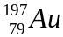. Clarify what this tells you about the gold atom.

- It contains 118 protons.
- It contains a total of 197 protons, neutrons and electrons.
- It contains 118 neutrons.
- It contains 197 electrons.

- What is the electronic configuration of a chlorine atom? Hint: Chlorine has an atomic number of 17.

- 2,2,2,2,2,2,2,2,1
- 2,8,7
- 8, 8, 1
- 2,10,5

- Aluminium-28 decays according to the following equation:
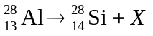
Identify the particle X.
- neutron
- alpha particle (helium nucleus)
- beta particle (electron)
- proton

- A radionuclide is:

- a radioactive isotope.
- a charged atom
- an element that emits beta radiation.
- an atom with the same number of protons but a different number of neutrons.

- The mass number of an atom is the number of

- neutrons in its nucleus.
- electrons in the nucleus.
- protons in the nucleus.
- protons plus neutrons in the nucleus.

- The number of electrons in each shell of an atom is known as its
- electron configuration.
- electron shells.
- atomic symbol.
- mass number.

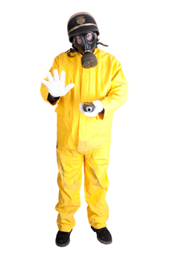
- Scientists use the process of decay in radioactive isotopes called to determine the of organisms.

- aging; carbon
- radioactive aging; carbon
- dating; age
- carbon dating; age


SEMESTER ONE 2017
Chemistry Test:
ANSWER BOOKLET
NAME:
FORM: DATE:

Multiple Choice Short Answer Extended Response Total

/10

/18

/33

/5

SECTION ONE: Multiple choice answers
Cross (X) through the correct answer.

1 | a | b | c | XXX
2 | a | XXX | c | d
3 | a | b | c | XXX
4 | a | b | XXX | d
5 | a | XXX | c | d
6 | a | b | XXX | d
7 | XXX | b | c | d
8 | a | b | c | XXX
9 | XXX | b | c | d
10 | a | b | c | XXX

SECTION TWO: Short Answer (18 marks)
Answer the questions in the spaces provided.

Question 11

Identify the number of protons, neutrons and electrons in the atoms of tin: (1 mark)

- protons: 50
- neutrons: 68
- electrons: 50

Must have all 3 correct for 1 mark

Question 12

Describe how a stable atom changes if you change the number of: (3 marks)
- electrons

Changing the number of electrons results in a charged atom (1/2), called an ion (1/2)
- neutrons

Changing the number of neutrons results in a different atomic mass (1/2), called an isotope(1/2)
- protons

Changing the number of protons results in a different atomic number (1/2) and the atom becomes a new element (1/2)

Question 13
Construct electron shell diagrams and write the electron configurations for the following atoms. (4 marks)

a. Oxygen
Electron shell diagram:
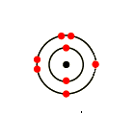

Electron configuration:
2, 6
b. Lithium
Electron shell diagram:
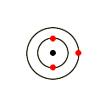

Electron configuration:
2, 1

Question 14
Carbon has different isotopes, as shown in the diagram below.
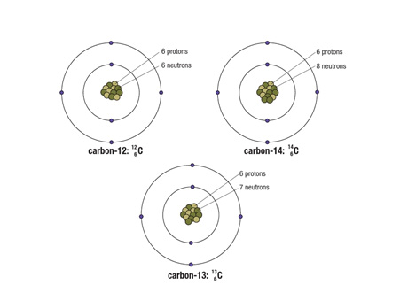
Describe the similarities and differences between these shown. (3 marks)

Any 3 of the following points for 1 mark each:
- All of the atoms of carbon have the same atomic number = 6 = number of protons
- Each of the atoms is a different isotope of carbon, which means that they have different numbers of neutrons in the nucleus
- The first isotope, with the mass number of 12, has 6 neutrons
- The second isotope, with the mass number of 14, has 8 neutrons
- The third isotope, with the mass number of 13, has 7 neutrons

Question 15
Compare and contrast alpha, beta and gamma decay of radionuclides. (3 marks)

TYPE OF DECAY | COMPARE AND CONTRAST
ALPHA | Alpha decay emits particles (1/2) that are helium nuclei (1/2)
BETA | Beta decay emits particles (1/2) that are electrons (1/2)
GAMMA | Gamma decay emits energy/electromagnetic radiation (1) that are instead of particles

Question 16
The atoms below are written using the letters V to Z instead of their correct chemical symbols.
  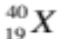 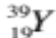 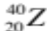 (4 marks)
- Which two atoms have the same number of neutrons?
Y and Z
- Which atom has the smallest mass number?
W
c) Which two atoms belong to the same element?
X and Y
- Which atom has the electron configuration 2, 8?
W
SECTION THREE: Extended Response (5 marks)
Select ONE of the following questions and write the question number in the box below. Answer the question in the space provided.
- Explain why oxygen atoms ionise to form the oxide ion with a charge of –2. Identify if oxide is an anion or a cation.
- Explain why radiation is dangerous for living cells but can be applied to treat people with some forms of cancer.
1
Question Number:

1 mark for each of the following points or similar reasonable response:
- When atoms ionise, only the valence electrons are affected
- Oxygen atoms have an electron configuration of 2, 6 and so have 6 valence electrons
- Outer electron shells are stable when they are full and it is easier to gain two electrons that to lose six, therefore oxygen atoms gain 2 electrons
- Each electron has a charge of -1, so gaining 2 electrons results in an overall charge of -2
- Oxide is a negative ion, so it is an anion
2
Question Number:

1 mark for each of the following points or similar reasonable response:
- Radiation is a form of energy that can affect the structure of other atoms if they come in contact
- Most often the number of electrons in the outer shell of an atom is affected and free radicals are formed
- Free radicals can damage cells, and in particular can affect the structure of DNA
- Damaged DNA can result in a large number of diseases and mutations, including many cancers
- However, radiation can also treat cancer by deliberately causing more damage to the cancer cells, enough to destroy them

END OF TEST
Please check your work!

